**Suwannakudt, Paiboon (1925-1982)**

Paiboon Suwannakudt (Tan Kudt) was a neo-traditional Thai painter, who is credited as being one of the key figures in the modern reinvigoration of Thai mural painting. A graduate from the first group of students to study at the School of Fine Arts (later Silpakorn University), Paiboon originally wanted to be a sculptor like his teacher, Silpa Bhirarsri, but was encouraged to learn mural painting instead. From the reign of Rama V (r. 1868-1910), the Thai elite’s preferences for European art forms meant that by the 1950s Thai mural painting was a stagnant practice. Silpa Bhirasri’s encouragement of Paiboon to take up mural painting may then be viewed as part of his wider interest in the reinvigoration of traditional Thai art practices and their acceptance as legitimate fine art forms. Throughout the 1950s and 1960s, Paiboon studied painting by making visits to craftsmen working in the mural painting tradition and by copying murals at several temple compounds, including Wat Po, which is located near Silpakorn University. Paiboon’s work and his position as an artist were emblematic of a neo-traditional position: while he maintained a certain level of fidelity to the notion of tradition through his choice of subject matter and careful study of mural conventions, he also professed a degree of creative variation from traditional norms and a certain level of anti-conservatism.

Paiboon Suwannakudt was born in Ubon Ratchathani, and began his study at the School of Fine Arts in 1938. In 1944, he recommenced his studies with Silpa Bhirasri at Silpakorn University, and received his diploma in 1948. After teaching at Sirisart School for two years (1950-2), Paiboon began work as a dancer and a dance teacher, also working on set designs for the National Theatre. He was also recognised as an author, in 1969 publishing the short story *Khiao Mu Pa* (*Wild Boar*) in a volume of collected poems and short stores, edited by the radical author and National Artist (literature), Rong Wongsawan (1935-2009).

Paiboon’s political leanings and activist activities undertaken throughout his life demonstrated his anti-conservative leanings, which to some extent complicate his position as a practitioner of a traditional art style. In 1957 he joined protests against Field Marshal Phibun’s regime and in the 1970s, he also developed associations with two radical Thai artists: poet and painter Tang Chang (1934-199) and painter Pratuang Emjaroen (b.1935). After the violent reaction against student protestors in 1976, he also gave money to leftists who were on the run from right wing groups.

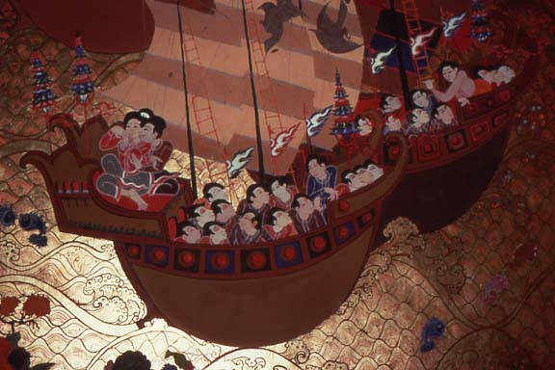

Paiboon Suwannakudt, *Detail from Mural at Monthien Hotel*, 1970. Copyrights???

From the 1960s onwards Paiboon completed many large mural works in major hotels, temples and palaces in Thailand, including the Monthien Hotel (1967-8); Phuphing Rajaniwet Palace, Chiang Mai (1969); Dusit Thani hotel (1970); and the Dusit Palace reconstruction at Muang Boran, Samut Prakan (1973). His final project at The Bangkok Peninusula Hotel, Ratchadamri (1980) was completed by his team under the leadership of his daughter Phaptawan Suwannakudt, (b. 1959) after his death. Paiboon’s adoption of the traditional style of mural painting also required that he employ several student apprentices, who later formed the ‘Tan Kudt Group.’ Many of these have since gone on to become highly regarded artists in their own right, including Panya Vijinthanasarn (b. 1956) and Phaptawan Suwannakudt.

**List of Works**

Paiboon Suwannakudt (1969) ‘Khiao Mu Pa’ (Wild Boar), in Rong Wongsawan, ed. *Kanyayon Nalin*  (*September Issue*), Bangkok: Samnakphim Fa Muangthai. (In Thai)

Paiboon Suwannakudt (1975) ‘Som Poy Dok Luang’ (The Yellow Flowers of the Soap Pod Plant), in Suchat Sawatsi ed. *Laeng Khen: Ruam Ruang San Samai Khong Thai*, Bangkok: Samnakphim Duangkamon. (In Thai)

**References and Further Reading**

---- (1995) *10 Pi Klum Than Kudt* (*Ten Years of the Than Kudt Group*), Bangkok: The Place of Art (In Thai and English)

An exhibition catalogue that includes details of works of several of Paiboon Suwannakudt’s apprentices. Includes also an essay on Neo-traditionalism by John Clark and a short biographical entry on Paiboon.

Clark, John (2010) *Asian Modernities: Chinese and Thai Art Compared, 1980-1999*, Sydney: Power Publications. See p. 140-1.

Details of Paiboon’s life and practice are included in this book as part of a larger discussion on the role of neo-traditional art in Thailand.

N.N. Paknam (1983) ‘Paiboon Suwannakudt’, in *Lok Sinlapa* (*Art World*), Vol. 3, No. 1, p. 30-40. (In Thai)

Srisak Nopparat, ed. (1982) *Paiboon Suwannakudt* (Cremation volume), Krung Thep (Bangkok): Sahatsan Kanphim. (In Thai)

This volume was published by Paiboon’s family and includes his autobiographical essay written in 1981, after he knew his illness would be terminal.

Wiboon Lisuwan (1993) ‘Paiboon Suwannakudt: Phubutberk Ngan Jitrakam Thai Ruam Samai’ (Paiboon Suwannakudt: Pioneer of Contemporary Thai Painting), in *Hi Class Magazine*, Vol. 10, No. 114, p. 144-147. (In Thai)